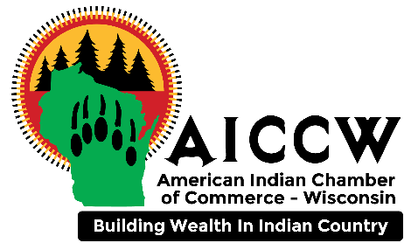
Wisconsin Tribal Nations Economic Development Resources Toolbox Tour - Roadmap

Intent
- Wisconsin Tribes have increased awareness of and access to resource providers and opportunities.
- Resource providers have increased awareness of Tribal Nations and priority development opportunities/needs.
- Projects are aligned and engaged with resources.

Teams
Planning team  - Tom Baron, Economic Development Administration  - Gary Mejchar, American Indian Chamber of Commerce of Wisconsin, Inc.  - Diane House, Great Lakes Inter-Tribal Council  - Aina Vilumsons, Wisconsin Procurement Institute  - Mary Owen-Thomas, EDA | Tribal team (recommendations)  - Main point of contact  - Planning  - Grant Writers  - Tribal Historic Preservation Office (THPO)  - Roads/Infrastructure  - Environmental/Forest Management  - Housing  - College Resources  - Economic Development  - Elected Officials on Economic Development committees
Resource providers  - Federal agencies  - State agencies  - Regional agencies  - Non-profit organizations | Tribal stakeholders (recommendations)  - Elected officials  - Economic development professionals  - Business owners/operators  - Tribal Enterprise/Business Development Corporation Representatives  - Other interested parties
Roadmap
Item and timeframe | Notes | People
1. Initial discussion  3 months before event | - Discuss past events.  - Talk about Tribal team role and make up.  - High-level overview of roadmap and agenda templates.  - Discuss event time, location, and type (online, in-person, hybrid).  - Discuss Tribal stakeholders as attendees and other invited community attendees | -Tribal representatives  -Planning team
2. Presentation development  2 months before event | - Meet with tribal core team to discuss presentation and its use at the event.  Uses for presentation  - Provide overview of Tribe including strengths and challenges.  - Development of breakout rooms based on presentation.  -Option #1. Breakout rooms based on upcoming tribal projects in need of resources – hosted by tribal project lead staff.  -Option #2. Breakout rooms based on themes (entrepreneurship, capacity building, tourism, etc.). | -Tribal team  -EDA public affairs staff
3.Outreach to resource providers and technology host  2 months before event | - Save the date emails.  - Coordination with technology host. | -Planning team
4. Agenda development  1 month before event | - Agenda is developed by Planning team and  - The agenda is reviewed and approved by the Tribal team. | -Planning team  -Tribal team
5. Rehearsal  Week of event | - Rehearsal using technology platform – virtual  - Rehearsal integrating tech platform and onsite event management – hybrid  - Rehearsal for live onsite event | -Planning team  -Tribal team  -Resource providers
6. Event  Selected date | Refer to event agenda | -Planning team  -Tribal team  -Tribal stakeholders  -Resource providers
7. Debrief  One week after event | Call to discuss  - Connections with Resource Providers  - What went well  - What to change for future events | -Planning team  -Tribal team
8. Follow up  One month after event | - Connect tribe and select resource providers for specific projects and alignments.  - Prepare and distribute local Tribal Development Resource Directory (may go out in advance of event) | -Planning team  -Tribal team  -Resource providers

